**Friday Update, April 26, 2024**

Good evening Sulphur Springs Families and staff, this is Dr. Catherine Kawaguchi, your Superintendent with your Friday update, April 26, 2024.





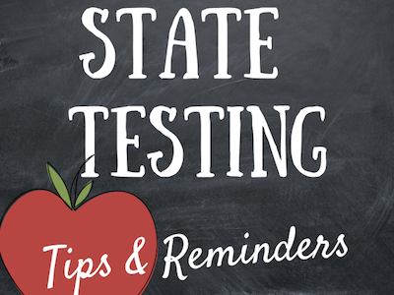

Some of our 3rd through 6th grade students will begin state testing in English Language Arts, mathematics and science (5th grade only) this coming week and will continue through the month of May. As we approach the state testing period, I want to take a moment to reach out and provide some information and support.

State testing can sometimes feel stressful, both for students and for families. It is natural to want your child to do well, but it is also important to remember that these tests are just one measure of their progress.

Here are a few things to keep in mind:

1. **Encouragement**: Offer your child words of encouragement and support. Let them know that you believe in their abilities and that you're proud of their efforts, regardless of the outcome.
2. **Stay Positive**: Try to maintain a positive attitude about the testing process. Remind your child that it's an opportunity to show what they've learned and to practice important skills like focus and perseverance.
3. **Healthy Habits**: Encourage your child to get plenty of rest leading up to the test days and to eat a healthy breakfast. A well-rested and nourished mind is better equipped to perform at its best.
4. **Perspective**: Help your child keep things in perspective. Tests are important, but they're not the only measure of success. Emphasize the value of learning for its own sake and the growth that comes from facing challenges.
5. **Open Communication**: Keep the lines of communication open with your child's teachers. They can provide additional support and resources to help your child prepare for the tests.

Please remember that we are all in this together. Your support and encouragement mean a great deal to your child, so thank you for being such an important part of their educational journey.

Always remember that if you have any questions about the state test, to reach out to your child’s teacher or principal. They will be happy to answer questions and support your child.



**Educational Partner Meetings**

I will be hosting Parent/Guardian Informational/Input Meetings regarding the District’s proposed Local Control and Accountability Plan (LCAP) for the 2024-2025 school year on **May 7th at 6:00 PM**. The Zoom link to join these meetings can be found on the District’s [website.](https://www.sssd.k12.ca.us/) The District’s LCAP outlines to parents and staff how the District intends to meet its annual goals and actions for all students, with specific activities to address state and local priorities. We look forward to seeing you on Zoom!

Wishing you and your family a wonderful weekend. Thank you.

